**DIGITAL NURTURE 4.0 DEEP SKILLING JAVA FSE-WEEK1**

**NAME: SIVITHA GUNASEKARAN**

**SUPERSET ID: 6413354**

**WEEK 1: DESIGN PATTERNS AND PRINCIPLES**

**Exercise 6: Implementing the Proxy Pattern**

**Scenario:**

You are developing an image viewer application that loads images from a remote server. Use the Proxy Pattern to add lazy initialization and caching.

**Steps:**

1. **Create a New Java Project:**
   * Create a new Java project named **ProxyPatternExample**.
2. **Define Subject Interface:**
   * Create an interface Image with a method **display()**.
3. **Implement Real Subject Class:**
   * Create a class **RealImage** that implements Image and loads an image from a remote server.
4. **Implement Proxy Class:**
   * Create a class **ProxyImage** that implements Image and holds a reference to RealImage.
   * Implement lazy initialization and caching in **ProxyImage**.
5. **Test the Proxy Implementation:**
   * Create a test class to demonstrate the use of **ProxyImage** to load and display images.

**CODE SAMPLES:**

interface Image {

void display();

}

class RealImage implements Image {

private String filename;

public RealImage(String filename) {

this.filename = filename;

loadFromDisk();

}

private void loadFromDisk() {

System.out.println("Loading image: " + filename);

}

public void display() {

System.out.println("Displaying image: " + filename);

}

}

class ProxyImage implements Image {

private RealImage realImage;

private String filename;

public ProxyImage(String filename) {

this.filename = filename;

}

public void display() {

if (realImage == null) {

realImage = new RealImage(filename);

}

realImage.display();

}

}

public class ProxyPatternExample {

public static void main(String[] args) {

Image image1 = new ProxyImage("car.jpg");

image1.display();

image1.display();

}

}

**OUTPUT:**

**Loading image: car.jpg**

**Displaying image: car.jpg**

**Displaying image: car.jpg**

**MY SCREENSHOT PROOFS:**

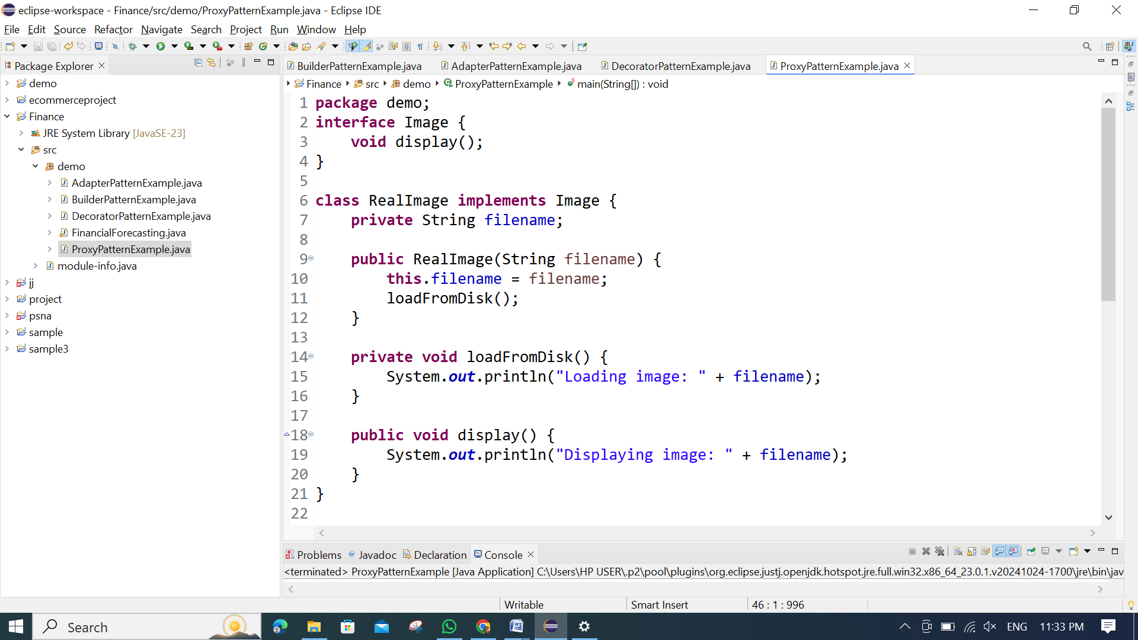

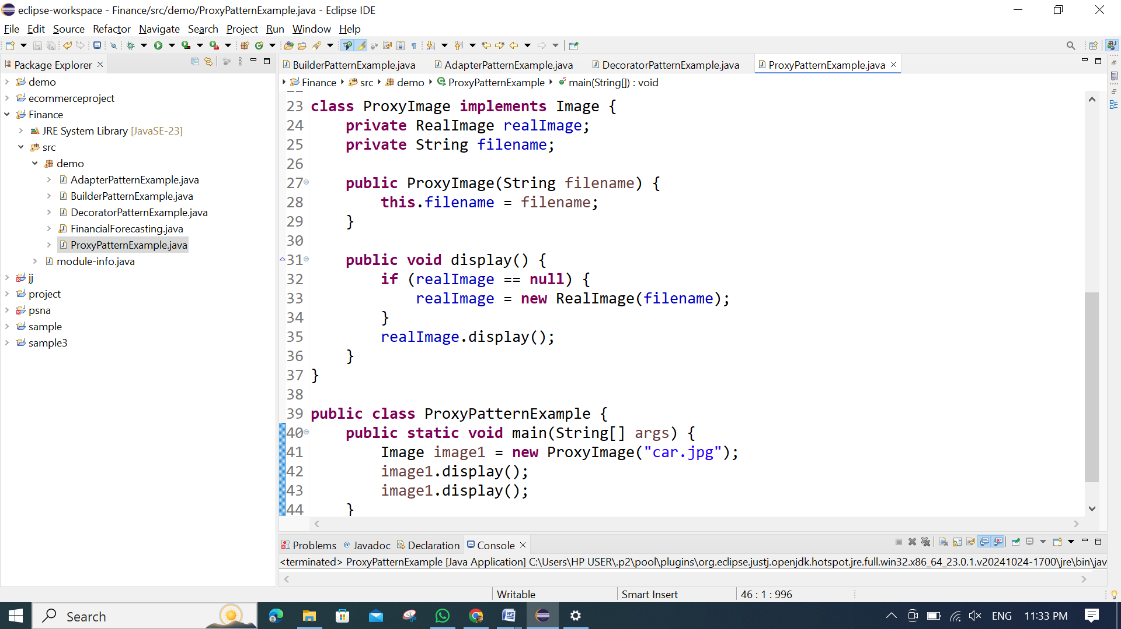

**OUTPUT:**

